**Experiment 1**

WinSCP. This screenshot shows adding the files to the Hadoop home cluster.

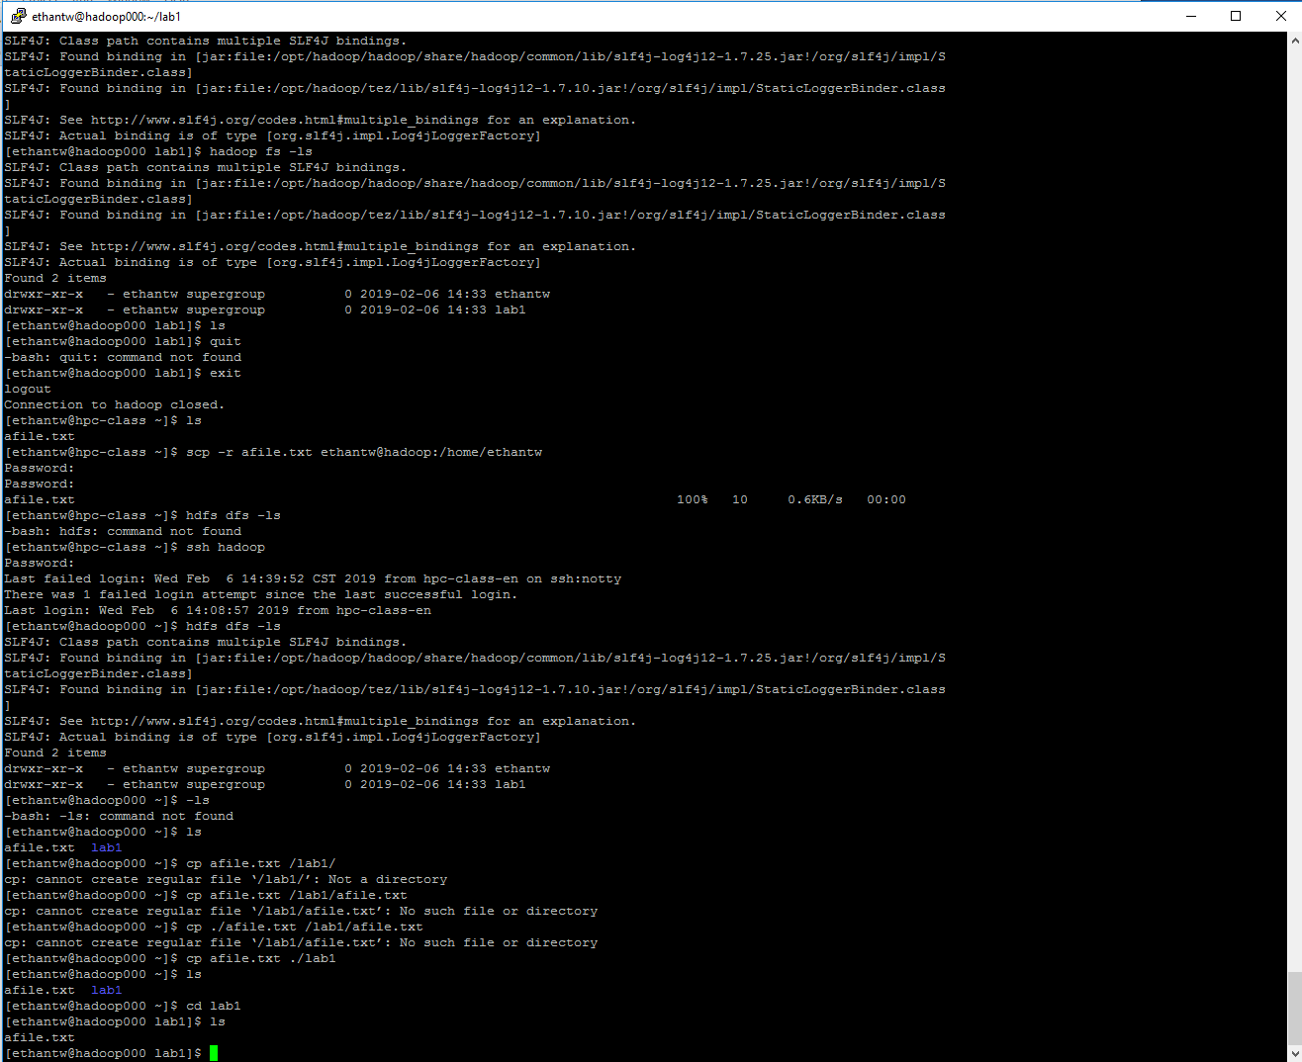

Java:

Put the jar file on the Hadoop home cluster. This is a screenshot containing the output of the HDFSWrite class.

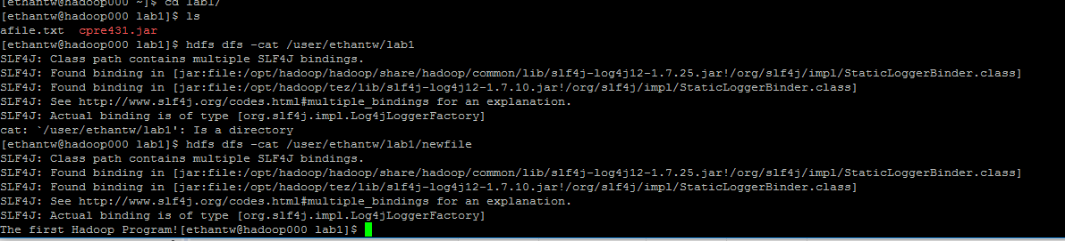

Experiment 2:

This shows the output of running my code against the provided file.

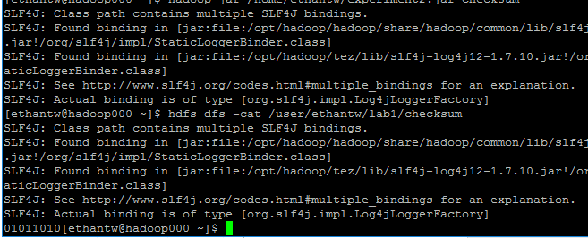

**Output is 01011010**

Code is attached.